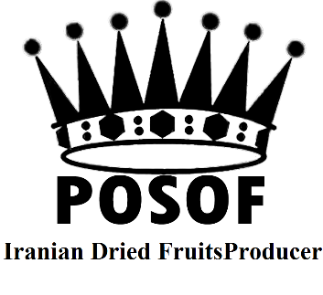
POSOF Dried Fruits
Factory address: Hossein Abad-e SAIN QALEH-SAIN QALEH City-ZANJAN -IRAN
Mr. HAMID VAEZI
Tel: +982435621893&1895
Fax: +982435621894
Iranian Nutrition and Dried
Fruits Processing Co.
ID: 0057604894
Mob: +989126935510 & +989121417155
Web: www.posof.ir
Gmail: export.posof.ir@gmail.com

General Specification
Grade RTU
Till May After May
Type of goods: Standard Sultanas Raisin Type of goods: Standard Sultanas Raisin
Count /100 gr: 280-360 Count /100 gr: 300-390
CAPSTEMS: 5 free CAPSTEMS: 3 free
Moisture: 12-14 Moisture: 11-13
Moldy Berries: Zero Moldy Berries: Zero
Undeveloped Berries: 0.1% Undeveloped Berries: 0.5%
Sugared Berries: Zero Sugared Berries: 0.2%
Stalks free: (Pieces /Box) Zero Stalks free: (Pieces /Box) Zero
Foreign Materials: Zero Foreign Materials: Zero
Jumbo Berries: 0.05% Jumbo Berries: 0.05%
Hard Seeds: 0.001% Hard Seeds: 0.001%
Odor: Typical fruity odor and free of foreign odor
Color: Normal Brown Color: Normal Brown
Fumigation: Not need Fumigation: Need

Double Washed
Laser Sorted
X – Ray Sorted
Metal Detected
Oil: %100 sunflower oil – absolute–(3-6)/1000
Sulphur: Less
Fumigated under plastic tents with ALUMINUM PHOSPHIDE (PH3) 3 gr/m³ -72 hours- 30 Deg.C⁰
ISO: 22000 certify
Signature & stamp HAMID VAEZI (POSOF)

